CHAPTER 4

ANALYSIS AND DESIGN

Use Case Specification and UML Diagrams
Generate Report

4.1 Introduction
This document presents the detailed design of the fourth use case of the PSM Assessment System, namely Generate Report. The use case covers the coordinator's dashboard, which summarises the progress, risk and marks of a cohort, and the CSV exports that the coordinator downloads for the faculty. It is specified in Table 4.4, then expressed as a sequence diagram in Figure 4.7 and an activity diagram in Figure 4.8.

4.2 Use Case Specification
Generate Report answers questions about a whole batch rather than about one project, so every report is built from the same three filters: the batch, the PSM part and the academic semester. The system produces two kinds of output from those filters. The on-screen report returns figures as JSON for the dashboard to render, and the export produces a CSV file. Table 4.4 summarises the use case.
Table 4.4: Use Case Specification for Generate Report
Use Case ID | UC-04
Use Case Name | Generate Report
Actor | Coordinator (primary), Admin.
Description | The coordinator selects a batch, a PSM part and a semester, and the system produces cohort analytics. The reports cover cohort progress, students at risk, supervisor and examiner workload, mark distribution and milestone breakdown. The coordinator may also export the grade or project list as a CSV file.
Pre-condition | The coordinator is signed in and holds the analytics permission. Projects and assessments exist for the selected filters.
Trigger | The coordinator opens the Reports screen, or clicks Export.
Main Flow | 1. The coordinator opens the Reports screen.  2. The coordinator chooses the batch, the PSM part and the semester.  3. The coordinator requests the report.  4. The system checks the analytics permission.  5. The system validates the filters and resolves the semester.  6. The system runs the aggregate query for the chosen filters.  7. The system computes cohort progress from the milestone statuses.  8. The system counts submissions awaiting review.  9. The system identifies the students at risk.  10. The system computes the mark distribution.  11. The system builds a rollup for each PSM part.  12. The system returns the figures as JSON.  13. The interface renders the tables and charts.
Alternative Flow | A1. Permission refused: the system returns 403 Forbidden because the user may not view cohort analytics.  A2. Invalid filter: the system rejects a semester that does not exist or a PSM part other than PSM1 or PSM2.  A3. Export chosen: the system checks the export permission, which is narrower than the analytics permission and is limited to coordinators and administrators.  A4. No released grades: the mark distribution returns empty bands and null statistics rather than zero, because no released mark is not the same as a mark of zero.  A5. Grade without a final mark: the row is included in the export with a blank verdict rather than marked Fail, and it is excluded from the displayed pass rate.
Post-condition | On success, the coordinator sees the figures for the selected filters, or receives a CSV file. Every export is recorded in the audit log with the term, batch and part that were used. No underlying project or assessment data is modified.

Two rules in Table 4.4 are worth noting because they are easy to get wrong. First, the on-screen pass rate counts released results only (A4), because a withheld mark is not a published one, while the exported spreadsheet deliberately includes provisional rows so that the coordinator has a working extract. The export therefore carries a Status column beside the pass or fail verdict, so that anyone recomputing the rate from the file filters on released rows. Second, a grade with no final mark is left blank rather than marked Fail (A5): no mark is not a failure.

4.3 Sequence Diagram
The sequence diagram in Figure 4.7 shows both outputs from the same screen. Six lifelines take part: the coordinator, the reports interface, the report controller, the reporting service, the grades and milestones data, and the audit log. The diagram is divided into the on-screen report and the CSV export.
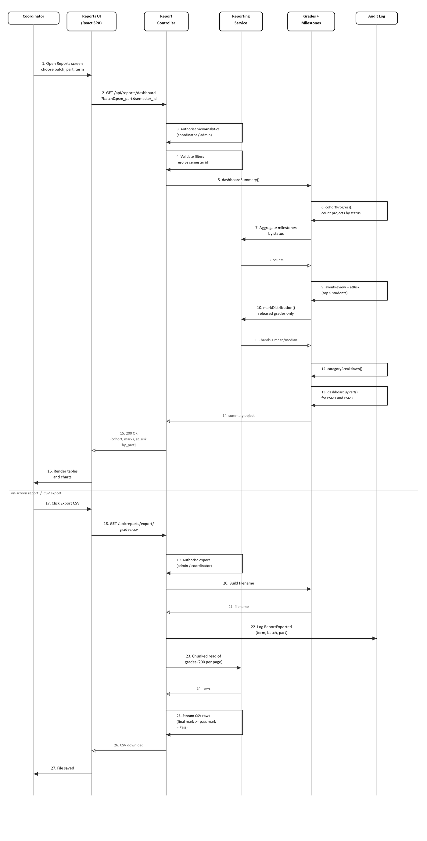
Figure 4.7: Sequence Diagram for Generate Report
Messages 1 and 2 carry the filter selection to the controller, which checks the analytics permission in message 3 and validates the filters in message 4. Message 5 hands the work to the reporting service. The service then performs a series of aggregations: message 6 counts projects by their milestone status, message 10 reads the released grades and computes the mark bands together with the mean and median, and messages 12 and 13 add the category breakdown and the per-part rollup. Message 14 returns the summary object and message 15 returns it to the interface, which renders the tables and charts in message 16.
The lower half of the diagram is the export path. Message 17 starts the export and message 19 applies the export permission, which is narrower than the analytics permission. Messages 20 and 21 build the filename from the term, part and timestamp. Message 22 writes the audit entry before any data leaves the system, so an export cannot happen without a record of it. Message 23 reads the grades in pages rather than all at once, because a full cohort export can run to thousands of rows, and message 25 writes each row as it arrives.

4.4 Activity Diagram
The activity diagram in Figure 4.8 shows the same use case as a workflow. After the permission check and the filter validation, a single decision splits the flow into the on-screen report, which continues down the centre, and the export, which runs down the right of the diagram. Both branches converge on one end node.
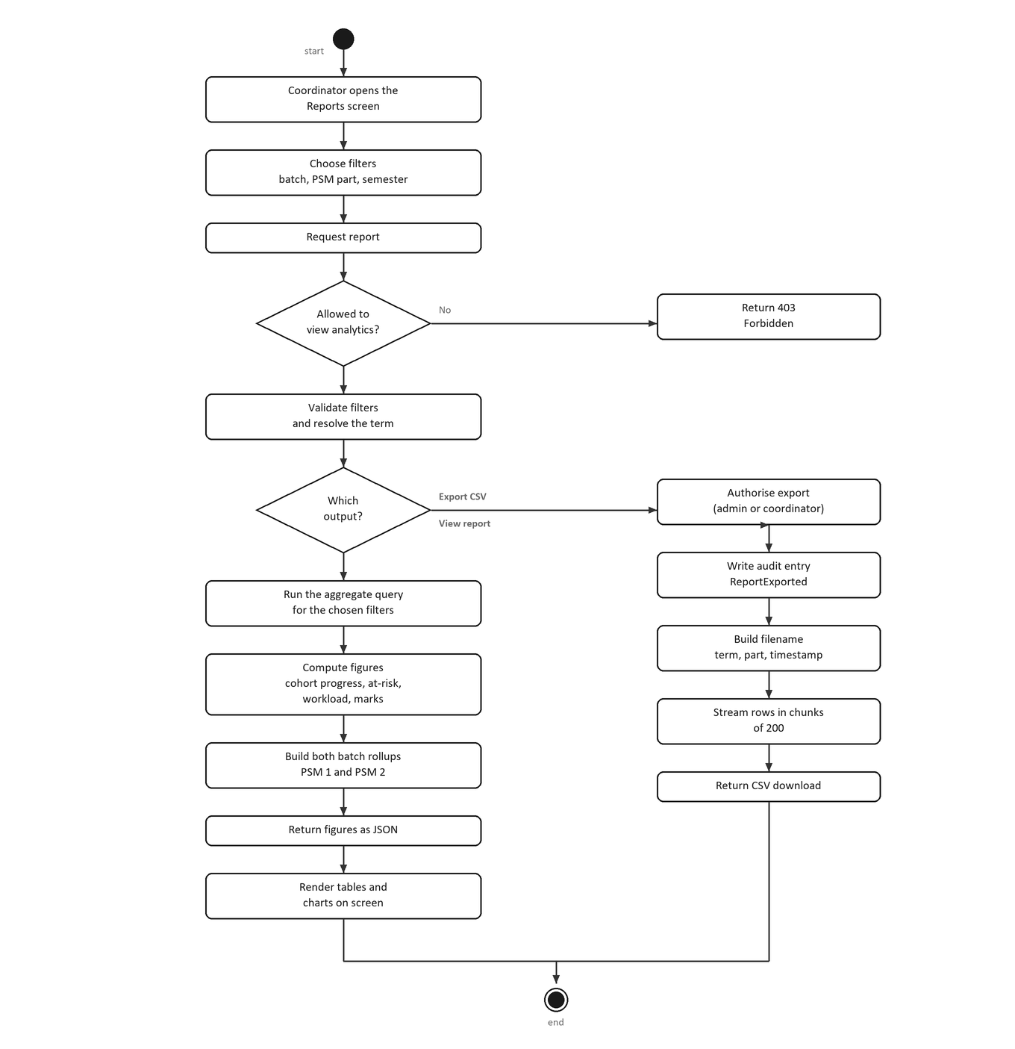
Figure 4.8: Activity Diagram for Generate Report
The first decision is the permission check, which corresponds to alternative flow A1: a user without the analytics permission receives 403 Forbidden and the workflow stops. The filter validation that follows is alternative flow A2. The second decision is the choice of output.
On the view branch, the system runs the aggregate query, computes the figures, builds a rollup for both PSM parts and returns JSON for the interface to render. On the export branch, the system applies the narrower export permission (A3), writes the audit entry, builds the filename, streams the rows in chunks of two hundred and returns the file. The streaming step is what keeps a large cohort export out of memory.

4.5 Chapter Summary
This document has specified the Generate Report use case and presented its sequence diagram and activity diagram. The specification defines the actors, a thirteen step main flow, five alternative flows and the post-conditions for both the on-screen report and the export. The sequence diagram shows the two outputs from one screen as message exchanges across six objects, and the activity diagram shows the flow as a workflow with a permission check, a filter check and a choice of output.

